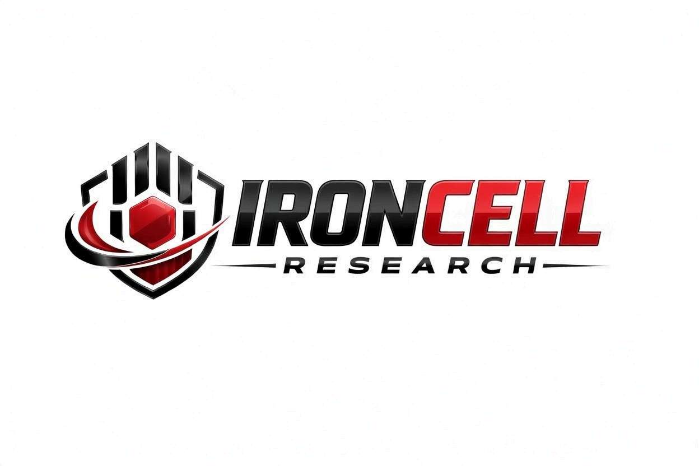
PEPTIDE RESEARCH BRIEF
KLOW
Research Peptide Blend | GHK-Cu + BPC-157 + TB-500 + KPV (80mg)

Description, Benefits, Dosage & Research Overview

Iron Cell Research
IronCellResearch.com
For Research Use Only


Compound Overview
Compound Name | KLOW
Classification | 4-Peptide Regenerative Blend (80mg total)
Amino Acid Sequence | GHK-Cu (Copper Tripeptide-1) + BPC-157 + TB-500 + KPV
Molecular Formula | Mixed (4-component blend)
Molecular Weight | Mixed (4-component blend)
CAS Number | N/A (multi-component formulation)
Biological Half-Life | Varies by component
Purity | Greater than or equal to 99%
Storage | Lyophilized, 2-8C, protected from light
Research Status | Active preclinical research (individual components)

Description
KLOW is a 4-peptide research blend supplied as an 80mg lyophilized powder vial. It combines four complementary peptides — GHK-Cu (Copper Tripeptide-1), BPC-157 (Body Protection Compound), TB-500 (Thymosin Beta-4 fragment), and KPV (Lys-Pro-Val) — each chosen for its distinct role in cellular repair, anti-inflammatory signaling, mucosal integrity, and tissue regeneration. Each component has independently published preclinical literature supporting its use as a research tool.
KLOW combines complementary mechanisms: GHK-Cu drives collagen synthesis and skin remodeling; BPC-157 promotes angiogenesis and tendon/tissue healing; TB-500 sequesters G-actin to accelerate cell migration and wound repair; KPV provides anti-inflammatory and antimicrobial signaling. Together these four peptides span four distinct repair axes in a single 80mg vial.
KLOW has gained research interest for laboratory study of combined regenerative pathways, gut and tissue barrier research, and recovery-related cellular mechanisms. For research use only — not for human consumption.

Mechanism of Action

Cellular Repair Pathways
BPC-157 in the blend upregulates VEGF/FGF-2 for angiogenesis and modulates NO signaling for vascular and tissue protection. TB-500 promotes cell migration to injury sites via G-actin sequestration. GHK-Cu binds copper ions and stimulates collagen, elastin, and glycosaminoglycan synthesis in fibroblasts.

Anti-Inflammatory Signaling
KPV in the blend is a C-terminal tripeptide of α-MSH studied for potent anti-inflammatory effects. It reduces NF-κB activation, TNF-α and IL-6 production. TB-500 and GHK-Cu add complementary anti-inflammatory and immunomodulatory signaling.

Mucosal & Barrier Integrity
The GH released in response to KLOW stimulates hepatic production of insulin-like growth factor-1 (IGF-1) and its binding proteins (IGFBPs). IGF-1 mediates many of GH's anabolic, lipolytic, and tissue-repair effects throughout the body. KLOW raises IGF-1 levels within the normal physiological range.

Protective Cellular Mechanisms
GHK-Cu modulates over 4,000 genes related to tissue remodeling and oxidative defense. BPC-157 shows broad cytoprotective effects in liver, kidney, brain, and cardiac injury models. KPV adds melanocortin-related cytoprotective signaling.

Research Benefits

Tissue Recovery Research
- Connective Tissue: BPC-157 directly stimulates tendon fibroblast outgrowth and tendon-bone healing. TB-500 promotes cell migration to injury sites. GHK-Cu drives collagen synthesis. KPV reduces local inflammation.
- Vascular Repair: BPC-157 and TB-500 both promote angiogenesis via distinct pathways. GHK-Cu supports vascular repair through copper-dependent extracellular matrix remodeling.
- Skin & Surface Tissue: GHK-Cu is a well-studied driver of collagen, elastin, and dermal remodeling. Combined with TB-500 (cell migration) and BPC-157 (angiogenesis), KLOW provides multi-pathway coverage for skin research.
- Joint & Cartilage: BPC-157 and KPV together address inflammatory cartilage research while GHK-Cu supports proteoglycan and collagen synthesis.

Gut & Mucosal Research
- Barrier Function: BPC-157 is one of the most-researched compounds for gut barrier integrity and intestinal mucosal recovery in preclinical models.
- Mucosal Healing: BPC-157 has extensive preclinical literature on gastric ulcer, IBD, and oral mucosal models. KPV adds local anti-inflammatory effect.
- Inflammation Modulation: KPV directly reduces NF-κB and pro-inflammatory cytokine production. Combined with BPC-157's mucosal protection, KLOW provides multi-target anti-inflammatory coverage.

Immune & Inflammation Research
- Cytokine Modulation: KPV reduces TNF-α, IL-6, and IL-1β. TB-500 modulates inflammatory cell recruitment. GHK-Cu has additional immunomodulatory effects via copper-dependent signaling.
- NF-κB Pathway: KPV is a direct NF-κB pathway inhibitor at low concentrations. BPC-157 also modulates inflammatory transcription pathways.
- Immune Tone: TB-500 and KPV both influence macrophage behavior; KPV shifts toward anti-inflammatory M2 phenotype in research models.

Anti-Aging & Recovery Research
- Cellular Regeneration: TB-500 promotes hair follicle and progenitor cell migration. BPC-157 enhances stem-cell-related repair signaling. GHK-Cu activates genes related to tissue renewal.
- Oxidative Stress: GHK-Cu binds copper which is essential to antioxidant enzymes (Cu/Zn-SOD). BPC-157 modulates oxidative damage in injury models.
- Healthspan Markers: GHK-Cu is one of the most researched anti-aging peptides; combined with BPC-157, TB-500, and KPV, KLOW covers a broad span of recovery pathways.

Research Status & Applications
- Research Use: KLOW is supplied as a research compound for laboratory and preclinical research applications only.
- Active Investigation: Component peptides are actively studied in academic and preclinical research worldwide.
- Combination Studies: Used in research alongside other interventions to study additive and synergistic regenerative effects.

Dosage & Administration
The following dosage information is provided for research reference purposes only. KLOW is for laboratory research use only and is not intended for human consumption.
Protocol | Dose Range | Route | Frequency
Standard | 1-2 mg | SubQ Injection | Daily
Low / Introductory | 500 mcg | SubQ Injection | Daily
Loading Phase | 1-2 mg | SubQ Injection | Daily
Maintenance | 1-500 mcg-1 mg | SubQ Injection | 2-3x per week

Reconstitution Guidelines
Solvent | Sterile bacteriostatic water
Reconstitution | 2-3 mL BAC water per 80mg vial
Mixing | Gently swirl until dissolved; do not shake
Storage | Refrigerate at 2-8C, use within 21 days
Injection Site | Subcutaneous, rotate sites; may inject near research target area
Timing | Per protocol; commonly evening dosing in published research

Safety Profile
KLOW components demonstrate favorable preclinical safety profiles:
- General Tolerability: Component peptides are generally well tolerated in preclinical research at typical doses.
- Injection Site Reactions: Mild transient redness or discomfort possible with subcutaneous administration.
- Arthralgia & Myalgia: Not commonly characteristic of the blend in research models.
- Peripheral Edema: Not commonly reported in research literature.
- Glucose Metabolism: No significant effects on glucose metabolism reported for the blend components.
- IGF-1 Monitoring: No routine monitoring required in standard preclinical protocols.
- Contraindications: Known hypersensitivity to any component. Limited safety data in pregnancy and lactation.

Key References
- Seiwerth S, et al. BPC 157 and Standard Angiogenic Growth Factors. Current Pharmaceutical Design. 2018.
- Pickart L, Margolina A. Regenerative and Protective Actions of the GHK-Cu Peptide. International Journal of Molecular Sciences. 2018;19(7):1987.
- Malinda KM, et al. Thymosin Beta-4 Accelerates Wound Healing. Journal of Investigative Dermatology. 1999.
- Hardman J, Hooper N, Turner A. KPV: a peptide with multiple immunomodulatory roles. Current Topics in Medicinal Chemistry. 2010.
- Khavinson VK. Peptidergic Regulation of Gene Expression and Cell Aging. Frontiers in Pharmacology. 2014.
- Chang CH, et al. The Promoting Effect of Pentadecapeptide BPC 157 on Tendon Healing. Journal of Pharmacological Sciences. 2011.
- Pickart L, et al. GHK Peptide as a Natural Modulator of Multiple Cellular Pathways in Skin Regeneration. BioMed Research International. 2015;2015:648108.

Contact & Information
Company | Iron Cell Research
Website | IronCellResearch.com
Email | orders@ironcellresearch.com
Product Support | Available via website contact form

Disclaimer
This document is intended for informational and research purposes only. KLOW is sold as a research compound and is not intended for human consumption. The information provided herein does not constitute medical advice, diagnosis, or treatment recommendations. All research applications should comply with applicable institutional, local, and federal regulations. Iron Cell Research makes no claims regarding the therapeutic efficacy of KLOW for any medical condition. Researchers should consult with qualified healthcare professionals and institutional review boards before initiating any research protocols involving human subjects.
Iron Cell Research - For Research Use Only


